Media Release: Immediate Release

JOB U Find your path to a successful career in a tough job market by Nicholas Wyman was officially released today. The book will be available Nationally and has won several International Awards.
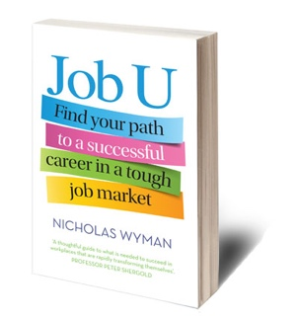
Some of the best jobs don’t require a university degree. It’s time to change the conversation. Companies often struggle to find employees with the skills they need, even amongst university graduates.

Today almost 800,000 Australians, many with university degrees, are unemployed. Yet half of all Australian businesses say they have trouble finding people with the practical, technical, job-ready skills they need.

“Unemployment and underemployment are at record highs; at the same time there are actually millions of jobs being left vacant or sent overseas,” Mr Wyman says.

“This mismatch is called Middle Skills Gap, or people without jobs and jobs without people as I call it – and its huge threat to the economy. People urgently need a new outlook and roadmap for how to find the best way to add value – and be valued- in today’s increasingly competitive job market.”

The good news is that there are still opportunities for a rewarding and well-paid career.
These opportunities can’t be found inside a traditional classroom, but rather in the educational options that provide the technical, vocational and soft skills that companies actually need. These include professional certifications, associate degrees, apprenticeships, and occupational learning.

“In order to solve the youth unemployment crisis, it is imperative that parents and students start considering alternatives to university,” Mr Wyman. “Staying employable, valuable and competitive in today’s rapidly changing workplace necessarily requires the constant acquisition of new skills.”
In Job U Australian workforce skills expert Nicholas Wyman shows how to find these
non-traditional pathways and get your dream job. Whether you are recent high school graduate, or well along in your career journey, Job U will help individuals find their way to a more secure and prosperous future.

What people are saying about Job U:
‘Three cheers for a provocative book that challenges young people to think carefully about how best to invest in their future. Education is vital – but so too, Wyman argues convincingly, are soft skills, practical training, entrepreneurial drive and emotional intelligence. Here is a thoughtful guide to what is needed to succeed in workplaces that are rapidly transforming themselves and in which traditional career paths are being disrupted or destroyed by organisational innovation.’
Professor Peter Shergold, Chancellor of Western Sydney University and Chair of the National Centre for Vocational Education Research
‘We need to focus on youth employment, and Nick Wyman’s strategies as always, are innovative and exciting.’
Martin Riordan, CEO, TAFE Directors Australia

‘Job U is a must read for any young Australian considering their future, and perhaps more importantly, for their parents and teachers. It dispels the long held belief that a rewarding career is reached exclusively via a university pathway by showcasing VET options as viable first-choice options that can lead to both individual and organisational success.’
Mark Callaghan, CEO, WorldSkills Australia

‘Career practitioners will find Job U a useful addition to their careers reference library.’
Bernadette Gigliotti, CEO, Australian Centre for Career Education

About the author:
Nicholas Wyman is a workforce development and skills expert, author, speaker, and CEO of the Institute for Workplace Skills and Innovation. Nicholas is a leader in developing skills-building, mentorship and apprenticeship programs that close the gap between education and careers around the world. A third-generation writer, Nicholas began his own career by learning a trade. He was named Australian Apprentice of the Year in 1988 and went on to captain Australia’s gold medal-winning Culinary Youth Team. He is a regular contributor to Forbes writing about job skills and training in the 21st-century workplace. He also writes features for Huffington Post and CNBC. He has an MBA and has studied at Harvard Business School and the Kennedy School of Government and was awarded a Churchill Fellowship in 2012.Wyman has been voted the number one education writer of LinkedIn in 2015 and one of its #LinkedInTopVoices. Wyman is also the driving force behind bringing the new US school model pilot to Australia called P-TECH with support of IBM and the Australian Government.

The US edition of Job U (Penguin Random House) is the Winner of the 2015 International Book Awards Business: Careers category, and the winner of the 2015 USA Best Book Awards, Business: Careers category.

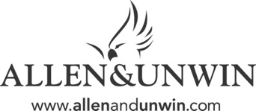
About the publishers: Allen & Unwin is Australia's leading independent publisher and has been voted "Publisher of the Year" twelve times including the inaugural award in 1992 and ten times since 2000.

Media contact: For interviews with Nicholas Wyman or to obtain a complimentary evaluation copy or attend one of the official release events in Melbourne(28th January), Brisbane (9 ^{th} February) Sydney (11th February) of Job U, please contact Communications Manager Antonia Maiolo on 0402648906 or email amaiolo@saf.org.au

